15.36: a) From Eq. (15.35),

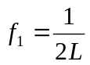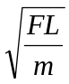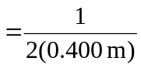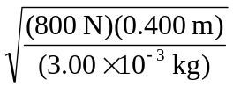=408 Hz.

b) 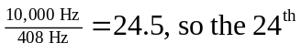 harmonic may be heard, but not the 